NEH Lesson Plan: The Most Southern Place on Earth: Music, History, and Culture of the Mississippi Delta

Submitted by: Carolyn Cagle

June 2018 Workshop

Jacqueline Smith: "Legacy" Vs "Gentrification"

Social Studies: Grade Five

Jacqueline Smith: "Legacy" vs. "Gentrification" will introduce the student to the effects political

decisions of governments have on the lives of people. Governmental decisions can have both positive and

negative effects on different people. Jacqueline Smith contends that she, and others of low income status,

became victims of "gentrification" occurring in her inner city community of Memphis, Tn. due to the

construction of a multimillion dollar museum to the "legacy" of Martin Luther King Jr. and the Civil

Rights Movement of the 1960's. Proponents of the museum see the museum as a "legacy" honoring Dr.

King and his achievements in the Civil Rights Movement: bringing prosperity to the inner city

community of Memphis, TN. Jacqueline Smith proposes that "gentrification" of the locale surrounding

the Lorraine Motel would not be what Martin Luther King Jr. fought for in the Civil Rights Movement.

Ms. Smith contends that a multi-million dollar museum would not be commensurate with Dr. King's

aspirations for the Civil Rights Movement, and instead of fostering a positive legacy for Dr. King, the

museum's legacy is one of inequality, displacement of lower income individuals, and misplaced

aggrandizement of the movement. While researching Ms. Smith, students will learn about the Dr. King

and the Civil Rights Movement of the 60s and will express their opinion of the opposing philosophies

presented by writing a personal opinion essay.

GSE: Georgia Standards of Excellence: Social Studies: Grade Five (Which standards are being specifically addressed in this lesson?)  SS5H6 Describe the importance of key people, events, and developments between 1950-1975.  a. Analyze the effects of Jim Crow laws and practices.  b. Explain the key events and people of the Civil Rights movement: Brown v. Board of Education (1954), Montgomery Bus Boycott, the March on Washington, Civil Rights Act, Voting Rights Act, and civil rights activities of Thurgood Marshall, Lyndon B. Johnson, Cesar Chavez, Rosa Parks, and Martin Luther King, Jr.  c. Describe the impact on American society of the assassinations of President John F. Kennedy, Robert F. Kennedy, and Martin Luther King, Jr.  SS5E1 Use the basic economic concepts of trade, opportunity cost, specialization, productivity, and price incentives to illustrate historical events.  a. Describe opportunity costs and their relationship to decision-making across time (e.g., decisions by individuals in response to rationing during WWII).  b. Explain how price incentives affect people’s behavior and choices (e.g., decisions to participate in cattle trails because of increased beef prices).  Map and Globe Skills  The student will use a map to explain the impact of geography on historical and current events. |  | Agenda: One Week Lesson Plan  - Statement of Standards.  - Teacher review of the legacy of Martin Luther King, Jr.: his character, his mission, his effect upon the history of the Civil Rights Movement in the 1960's  - Teacher introduction of Jacqueline Smith, the Lorraine Motel, and the National Civil Rights Museum At The Lorraine Motel.  - Small Group Investigation of the term "gentrification", Jacqueline Smith, the Lorraine Motel, and the National Civil Rights Museum At The Lorraine Motel.  - Small Group Presentation of investigation.  - Discussion of "legacy" vs. "gentrification".  - Evaluation: Student opinion essay.
Notes:

15 min. | Get started/Drill/Do Now:  Website tour of the National Civil Rights Museum At The Lorraine Motel.  www.civilrightsmusem.org |  | Teacher Observation of Students
10 min | Engage/Motivation:  Photograph of Ms. Cagle and Jacqueline Smith projected on media board for students to observe.  Question and Answer Session. |  | Teacher Observation of Students: Questions: Do you know who this is? What can you tell about this person's clothing? Can you identify where she is standing? What do notice in the photograph? Who is standing with this person?
20 min | Whole Group Instruction:  Review of Martin Luther King Jr. and the 1960's Civil Rights Movement. |  | Teacher Observation
30-40 min | Group Practice/Small Group Instruction:  Break into small group and distribute a different newspaper article to each group to read and discuss. Newspaper articles listed below in Resources. |  | Teacher Observation
 | Independent/Homework Practice:  Each student should be given a copy of the newspaper articles distributed to all Small Groups. Each student should choose two articles and read and highlight pertinent information. |  | Independent Practice and Homework: Teacher checked.
60 min | Presentation of Articles by Small Groups/Whole Group Discussion of Articles  Discussion is teacher lead. |  | Group participation checked by teacher.
60min | Evaluation  Teacher will assign three paragraph personal opinion essay for students to complete during class.  Students may use small group newspaper articles. |  | Written essay to be numerically scored.

Resources:

Classroom textbook.
Photographs of Jacqueline Smith and Ms. Cagle and Display. Attached.
Photograph of Dr. Martin Luther King, Jr. Teacher choice.
Jacqueline Smith Website: www.fulfillthedream.net
Jacqueline Smith Address: Jacqueline Smith, P.O.Box 3482, Memphis, TN 38173-0482
Dictionary source for "legacy" and "gentrification" definition.
National Civil Rights Museum Website: www.civilrightsmuseum.org
Viewpoint-The Memphis Commercial Appeal, April 2, 2018. Attached.
Highlighters.
Individual Student Copies of Articles Selected by Teacher Listed Below.
Wikipedia Newspaper Articles:
  - "Eviction Empties Motel Where Dr. King Died". The New York Times. March 3, 1988.
  - "Walter Bailey, Lorraine Motel Owner, 73". The New York Times. July 7, 1988.
  - "National Civil Rights Museum in Memphis Reopening". The New York Times. Associated Press. March 31, 2014. Retrieved March 31, 2014.
  - "We Are Prepared to Die: The Freedom Rides 1961". National Civil Rights Museum.
  - "A One-Woman Protest at the Lorraine Motel". Washington Post. May 16, 2014.
  - Parrish, Geov (February 14, 2001). "The Longest Sit (February 14, 2001)". Eatthestate.org. Archived from the original on June 9, 2007. Retrieved May 5, 2010.
  - Dean, Terry. "Side Trip – Jacqueline Smith's personal, and private, crusade". Austinweeklynews.com. Retrieved May 5, 2010.
  - Jordan, Mark (April 2, 1998). "News Feature". The Memphis Flyer. Retrieved May 5, 2010.
  - Chambers, Douglas B. (October–November 1999). "This Dreamer Cometh: The National Civil Rights Museum". American Visions. 14 (5): 40. Retrieved May 5, 2010 – via ebscohost.com.
  - Cornish, Audie (December 16, 2007). "Mission of National Civil Rights Museum Questioned". NPR. Retrieved February 13, 2015.

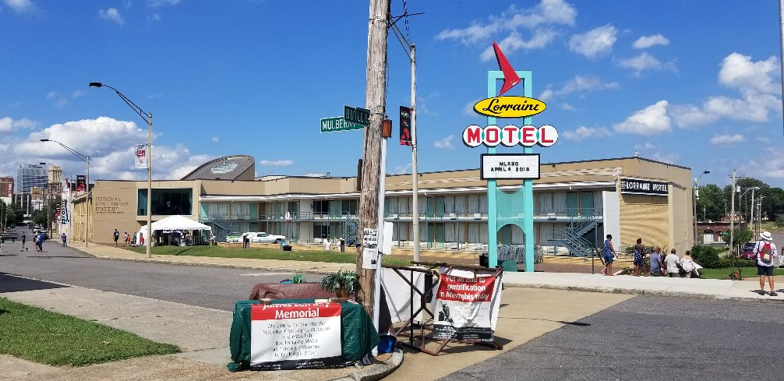

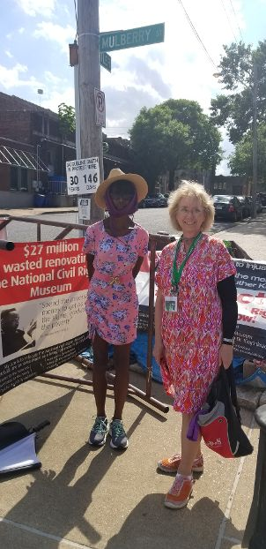

Jacqueline Smith and Ms. Cagle

